**Alexandru Vieru personal SWOT**

|  |  |
| --- | --- |
| Strengths | Weaknesses |
| * Hardworking * Efficient * Reliable * Tolerant | * Impatient * A bit inflexible * Stubborn * Slow to react |
| Opportunities | **Threats** |
| * Become better organized * Gain programing skills * Learn new skills * Time managing skills | * Getting bored * Becoming impatient * Sometimes distracted * Loosing motivation |

**Alexandru Vieru Belbin team roles**

According to Figure 1 below, my Belbin team roles are the following; implementor, shaper and coordinator.

**Figure 1 Belbin team roles chart**

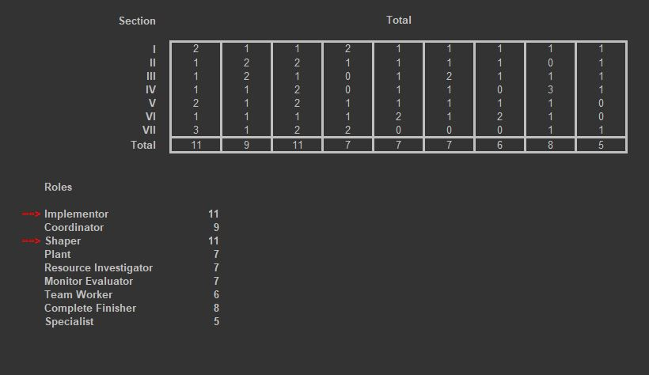

According to this, as an implementor, I focus on getting the job done, while being practical, reliable and efficient. By focusing on turning ideas into practice I contribute to the team by offering my organizational skills.

As weaknesses, I can sometimes be inflexible and slow to respond to new ideas and refuse to relinquish personal plans with new ones.

The same can be said about the shaper role since between the first two similarities arise.

As for the coordinator role I consider that I bring maturity and clear goals to the table, however sometimes I tend to neglect my work and prefer to pass some of my tasks to other team members.

For a more balanced overview of my Belbin team roles see figure 2 below.

**Figure 2 Personal Inventory**

